|  |
| --- |
| Athian Verifier Conflict of Interest Attestation |

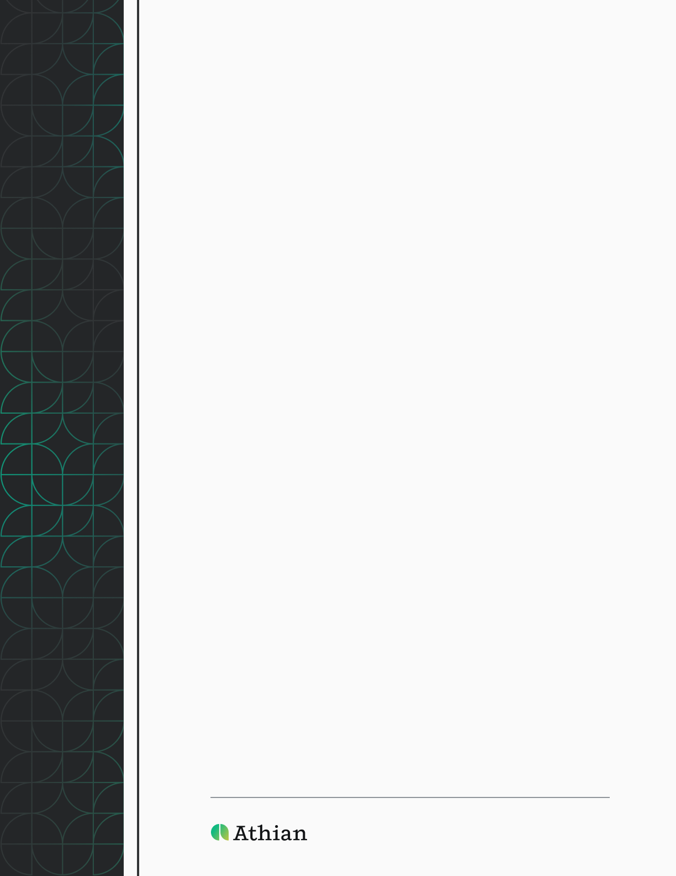

# Athian VVB Verification Conflict of Interest Form

Prior to performing any verification services for Athian, approved verification bodies are required to attest that no existing commercial, financial, personal, or organizational relationships would compromise their ability to perform an independent verification. This attestation should be completed for each project (which corresponds to the Intervention within the Athian platform) to which the verifier is assigned. If a change in the relationship occurs, the assigned verifier will disclose a new attestation.

If an independent observer raises concerns regarding the current or prior personal, family, or business relationships between the verification team and the protocol sponsor or the producer undergoing verification, these concerns will be evaluated and addressed prior to the commencement of verification.

The verifier will disclose all relationships within the past 12 months between the verifier and the protocol sponsor or the producer in question. Additionally, the verifier will attest that neither themselves nor any member of the verification team has a conflict of interest.

If no unresolvable conflicts of interest are identified, the verifier will complete this form and submit it to Athian via email at [info@athian.ag](mailto:info@athian.ag). Once received, and if the verifier is selected, they will be capable of completing verification services via the Athian platform for the producer in context.

# Conflict of Interest Determination

Please respond to each question with enough detail to adequately convey the situation, disclosing all relationships within the past 12 months. All information disclosed in this form will remain confidential and will only be used for the purposes of determining and mitigating the risks of any conflict of interest.

|  |  |  |  |
| --- | --- | --- | --- |
| Dates Applicable |  | | |
| Verifications Previously Completed for Producer | [ ] Yes | [ ] No |  |
| Protocol Name(s) |  | | |
| Protocol Sponsor(s) |  | | |
| Name of VVB |  | | |
| VVB Primary Contact |  | | |
| VVB Phone |  | | |
| VVB Email |  | | |
| VVB Address |  | | |
| Name of Producer to be Verified |  | | |
| Primary Contact |  | | |
| Producer Phone |  | | |
| Producer Email |  | | |
| Producer Address |  | | |

|  |  |  |  |
| --- | --- | --- | --- |
| Describe the VVB’s procedures for identifying potential conflicts of interest. |  | | |
| List all verification team members assigned to this project and their roles (Lead Verifier, Peer Reviewer, Technical Assistant, Other). |  | | |
| Has the verification body or any staff member assigned to the proposed verification, including while employed with another organization, ever provided GHG verification for this producer, even if under another GHG program, regulation, or registry? If yes, please describe. |  | | |
| Have you, or any staff working at your organization, consulted on or prepared any part of this project for the producer, or do you and the protocol sponsor or producer share any other formal affiliations? If yes, please describe. |  | | |
| Describe any other relationships between the VVB or the verification team with the protocol sponsor or the producer undergoing verification. |  | | |
| List any 3rd parties assisting the verification team with verification, if known/applicable. |  | | |
| Describe all relationships between the 3rd parties assisting the verification team and the protocol sponsor or producer undergoing verification. |  | | |
| Describe the VVB’s procedures to prevent and mitigate any potential conflicts of interest, and if applicable, how the VVB implemented the mitigation procedures. |  | | |
| Based on the above information, the VVB categorizes the risk of COI. | [ ] High | [ ] Medium | [ ] Low |

# Conflict of Interest Attestation

The verification body attests:

1. All potential conflicts of interest have been identified and mitigated
2. This form is true and accurate
3. The verifier will maintain the accuracy and completion of this form
4. The verifier will resubmit the attestation, should this information change

|  |  |
| --- | --- |
| **Signature:** |  |
| **Print Name:** |  |
| **Title:** |  |
| **Date:** |  |

|  |  |
| --- | --- |
| **Signature:** |  |
| **Print Name:** |  |
| **Title:** |  |
| **Date:** |  |